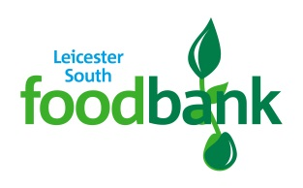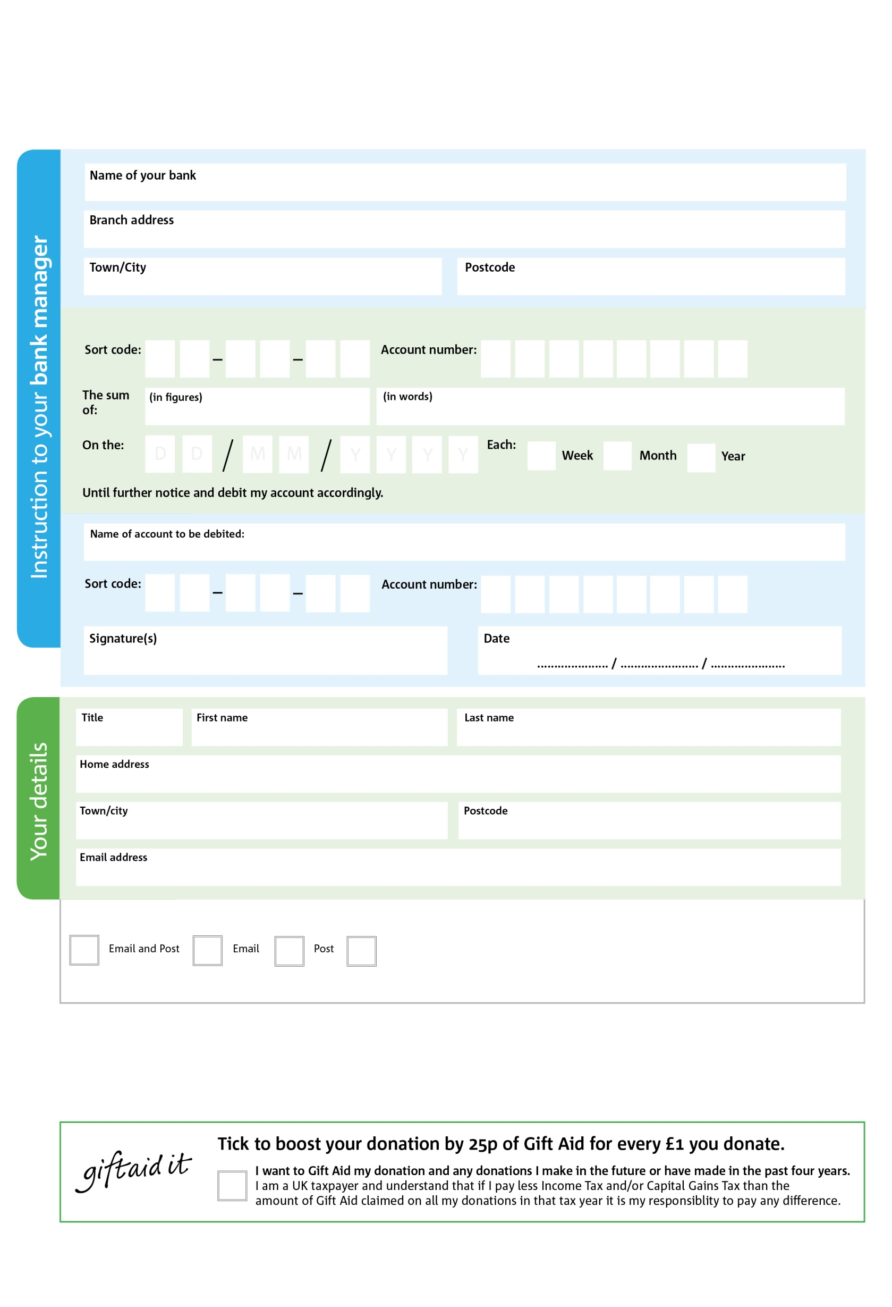

**Please pass this form onto the foodbank, using the foodbank’s address at the bottom, who will save a copy for their records.   
They will then send it onto your named bank or building society.**

Reg. Charity No: 1166104 | Reg. in England & Wales

**Data protection**

*'Leicester South Foodbank is committed to protecting your privacy and will process your personal data in accordance with current Data Protection legislation. Leicester South Foodbank collects information to keep in touch with you and supply you with information relating to our work. To unsubscribe from our newsletter, send a message to the email address above with the word unsubscribe in the subject line. A full data privacy statement for financial donors is available from the foodbank on request.’*

Leicester South Foodbank The King’s Centre, 56 Bull Head St Wigston,Leicester LE18 1PA

5

V

6

V

5

V

2

V

3

V

0

V

0

V

1

V

0

4

8

28

0

40

We would love to keep you up to date with information about Leicester South Foodbank. Please tick your preference:

You can change your preferences any time by contacting us on 07802 454740 or emailing us at info@leicestersouth.foodbank.org.uk

I do not wish to receive future communications from Leicester South Foodbank

Please pay Leicester South Foodbank,

**Standing Order Mandate**

**leicestersouth.foodbank.org.uk**

You can change your preferences any time by contacting us on XXXXXXXXXXX or emailing us at XXXX@XXXXXXXXXX.foodbank.org.uk

I do not wish to receive future communications from XXXXXX Foodbank